Jacky Rosen

**From Wikipedia, the free encyclopedia**

https://en.wikipedia.org/wiki/Jacky%20Rosen  
Licensed under CC BY-SA 3.0:  
https://en.wikipedia.org/wiki/Wikipedia:Text_of_Creative_Commons_Attribution-ShareAlike_3.0_Unported_License

# Jacky Rosen

* *She was elected to the U.S. Senate in the 2018 election, defeating Republican incumbent Dean Heller.*
* *She is the only freshman in the U.S. House of Representatives who won a seat in the U.S. Senate during the 2018 midterm elections and the only challenger to defeat a Republican incumbent U.S.*
* *Jacklyn Sheryl Rosen (née Spektor, August 2, 1957) is an American politician serving as the junior United States Senator from Nevada since 2019.*

Jacklyn Sheryl Rosen (née Spektor, August 2, 1957) is an American politician serving as the junior United States Senator from Nevada since 2019. A member of the Democratic Party, she previously was the U.S. Representative for Nevada's 3rd congressional district from 2017 to 2019.

She was elected to the U.S. Senate in the 2018 election, defeating Republican incumbent Dean Heller. She is the only freshman in the U.S. House of Representatives who won a seat in the U.S. Senate during the 2018 midterm elections and the only challenger to defeat a Republican incumbent U.S. Senator in the 2018 cycle.

# Early life and career

* *Rosen was born on August 2, 1957, in Chicago, Illinois, the daughter of Carol, a homemaker, and Leonard Spektor, a car dealership owner who had served in the U.S. Army during the Korean War.*
* *Rosen attended the University of Minnesota and graduated with a bachelor's degree in psychology in 1979.*

Rosen was born on August 2, 1957, in Chicago, Illinois, the daughter of Carol, a homemaker, and Leonard Spektor, a car dealership owner who had served in the U.S. Army during the Korean War. Her mother was of Irish, German, and Austrian descent, and her father's family were Jewish emigrants from Russia and Austria.

Rosen attended the University of Minnesota and graduated with a bachelor's degree in psychology in 1979. While she attended college, her parents moved to Las Vegas, where she also moved after graduating. She took a job with Summa Corporation, and worked summers as a waitress at Caesars Palace throughout the 1980s. While working for Summa, she attended Clark County Community College (now the College of Southern Nevada) and received an associate degree in computing and information technology in 1985. She began to work for Southwest Gas in 1990, and then left to open her own consulting business three years later.

# U.S. House of Representatives

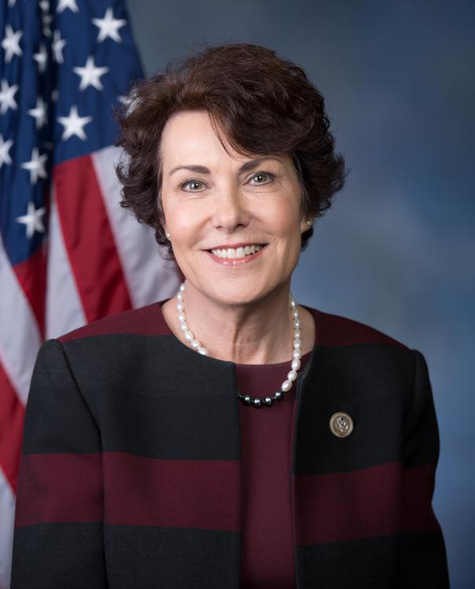  
*Rosen during the 115th Congress in the U.S. House*

# 2016 election

* *Rosen was sworn into office on January 3, 2017.*
* *Rosen won 60% of the vote in the Democratic Party primary election, and narrowly defeated Republican nominee Danny Tarkanian in the general election.*
* *On January 26, she officially declared her candidacy for Nevada's 3rd congressional district.*
* *A former computer programmer with no political experience at the time, Rosen was asked by then–Senate Minority Leader Harry Reid to run for the U.S. House seat vacated by Republican Joe Heck in the 2016 elections.*

A former computer programmer with no political experience at the time, Rosen was asked by then–Senate Minority Leader Harry Reid to run for the U.S. House seat vacated by Republican Joe Heck in the 2016 elections. On January 26, she officially declared her candidacy for Nevada's 3rd congressional district. Rosen won 60% of the vote in the Democratic Party primary election, and narrowly defeated Republican nominee Danny Tarkanian in the general election. Rosen was sworn into office on January 3, 2017.

# Committee assignments

* *Committee on Armed Services  
  Subcommittee on Military Personnel  
  Subcommittee on Tactical Air and Land Forces*
* *Committee on Science, Space, and Technology  
  Subcommittee on Energy  
  Subcommittee on Research and Technology*

Committee on Armed Services  
Subcommittee on Military Personnel  
Subcommittee on Tactical Air and Land Forces

Committee on Science, Space, and Technology  
Subcommittee on Energy  
Subcommittee on Research and Technology

# Caucus memberships

* *Congressional Arts Caucus*
* *Congressional Asian Pacific American Caucus*
* *Congressional Caucus for Women's Issues*

Congressional Arts Caucus

Congressional Asian Pacific American Caucus

Congressional Caucus for Women's Issues

# U.S. Senate

# 2018 campaign

* *She is also the 37th freshman member of the United States House of Representatives to win a seat in the Senate, and the first woman to do so.*
* *Rosen was one of only two non-incumbent Democrats to win election to the Senate in 2018.*
* *Rosen was elected to the U.S. Senate on November 6, 2018, becoming the junior Senator from Nevada.*
* *Ultimately, Rosen defeated Heller, the incumbent, by a 50.4%-45.4% margin.*

Rosen was elected to the U.S. Senate on November 6, 2018, becoming the junior Senator from Nevada. Her candidacy, announced on July 5 2017, was endorsed by former President Barack Obama and former Vice President Joe Biden. During the campaign, Rosen emphasized her support for the Affordable Care Act (Obamacare) and criticized Heller's vote to repeal it in 2017. At the time, Rosen voted against Republicans' attempts to repeal the Affordable Care Act.

Ultimately, Rosen defeated Heller, the incumbent, by a 50.4%-45.4% margin. While Heller carried 15 of Nevada's 17 county-level jurisdictions, Rosen carried the two largest, Clark (home to Las Vegas) and Washoe (home to Reno). She won Clark County by over 92,000 votes, almost double her statewide margin of over 48,900 votes.

Rosen was one of only two non-incumbent Democrats to win election to the Senate in 2018. She is also the 37th freshman member of the United States House of Representatives to win a seat in the Senate, and the first woman to do so.

# Committee assignments

* *Committee on Commerce, Science, and Transportation  
  Subcommittee on Aviation and Space  
  Subcommittee on Communications, Technology, Innovation, and the Internet  
  Subcommittee on Manufacturing, Trade and Consumer Protection  
  Subcommittee on Security*
* *Committee on Homeland Security and Governmental Affairs  
  Permanent Subcommittee on Investigations  
  Subcommittee on Regulatory Affairs and Federal Management*

Committee on Commerce, Science, and Transportation  
Subcommittee on Aviation and Space  
Subcommittee on Communications, Technology, Innovation, and the Internet  
Subcommittee on Manufacturing, Trade and Consumer Protection  
Subcommittee on Security

Committee on Health, Education, Labor and Pensions  
Subcommittee on Employment and Workplace Safety  
Subcommittee on Primary Health and Retirement Security

Committee on Homeland Security and Governmental Affairs  
Permanent Subcommittee on Investigations  
Subcommittee on Regulatory Affairs and Federal Management

Committee on Small Business and Entrepreneurship

Special Committee on Aging

# Political positions

* *as of March 2019[update], FiveThirtyEight found that Rosen had voted with President Trump's legislative positions approximately 40% of the time.*
* *Rosen has been described as a liberal Democrat at times and as a moderate at others.*

Rosen has been described as a liberal Democrat at times and as a moderate at others. as of March 2019[update], FiveThirtyEight found that Rosen had voted with President Trump's legislative positions approximately 40% of the time.

# Abortion

* *She is pro-choice on the issue of abortion and has been endorsed by NARAL Pro-Choice America.*

She is pro-choice on the issue of abortion and has been endorsed by NARAL Pro-Choice America.

# Foreign policy

* *In April 2019, Rosen was one of thirty-four senators to sign a letter to President Trump encouraging him "to listen to members of your own Administration and reverse a decision that will damage our national security and aggravate conditions inside Central America", asserting that Trump had "consistently expressed a flawed understanding of U.S. foreign assistance" since becoming president and that he was "personally undermining efforts to promote U.S. national security and economic prosperity" through preventing the use of Fiscal Year 2018 national security funding.*

In April 2019, Rosen was one of thirty-four senators to sign a letter to President Trump encouraging him "to listen to members of your own Administration and reverse a decision that will damage our national security and aggravate conditions inside Central America", asserting that Trump had "consistently expressed a flawed understanding of U.S. foreign assistance" since becoming president and that he was "personally undermining efforts to promote U.S. national security and economic prosperity" through preventing the use of Fiscal Year 2018 national security funding. The senators argued that foreign assistance to Central American countries created less migration to the U.S., citing the funding's helping to improve conditions in those countries.

# Gun policy

* *Rosen supports an assault weapons ban.*

Rosen supports an assault weapons ban.

# Health care

* *Rosen supports the Affordable Care Act and its provisions that prevent patients from being denied insurance or charged more due to age or having a pre-existing condition.*
* *In January 2019, during the 2018–19 United States federal government shutdown, Rosen was one of thirty-four senators to sign a letter to Commissioner of Food and Drugs Scott Gottlieb recognizing the efforts of the FDA to address the effect of the government shutdown on the public health and employees while remaining alarmed "that the continued shutdown will result in increasingly harmful effects on the agency's employees and the safety and security of the nation's food and medical products."*

Rosen supports the Affordable Care Act and its provisions that prevent patients from being denied insurance or charged more due to age or having a pre-existing condition. She supports allowing citizens to buy into Medicaid as an alternative option to compete with private insurance companies.

In January 2019, during the 2018–19 United States federal government shutdown, Rosen was one of thirty-four senators to sign a letter to Commissioner of Food and Drugs Scott Gottlieb recognizing the efforts of the FDA to address the effect of the government shutdown on the public health and employees while remaining alarmed "that the continued shutdown will result in increasingly harmful effects on the agency's employees and the safety and security of the nation's food and medical products."

In February 2019, Rosen was one of eleven senators to sign a letter to insulin manufactures Eli Lilly and Company, Novo Nordisk, and Sanofi over increased insulin prices and charging the price increases with having caused patients to lack "access to the life-saving medications they need."

# Housing

* *In April 2019, Rosen was one of forty-one senators to sign a bipartisan letter to the housing subcommittee praising the United States Department of Housing and Urban Development's Section 4 Capacity Building program as authorizing "HUD to partner with national nonprofit community development organizations to provide education, training, and financial support to local community development corporations (CDCs) across the country" and expressing disappointment that President Trump's budget "has slated this program for elimination after decades of successful economic and community development."*

In April 2019, Rosen was one of forty-one senators to sign a bipartisan letter to the housing subcommittee praising the United States Department of Housing and Urban Development's Section 4 Capacity Building program as authorizing "HUD to partner with national nonprofit community development organizations to provide education, training, and financial support to local community development corporations (CDCs) across the country" and expressing disappointment that President Trump's budget "has slated this program for elimination after decades of successful economic and community development." The senators wrote of their hope that the subcommittee would support continued funding for Section 4 in Fiscal Year 2020.

# Immigration

* *She supports "comprehensive immigration reform", although she does not believe the Immigration and Customs Enforcement agency should be abolished.*

She supports "comprehensive immigration reform", although she does not believe the Immigration and Customs Enforcement agency should be abolished.

# Taxation and employment

* *Rosen supports a $15 per hour minimum wage.*

She was one of three Democrats who broke with their party and voted to make individual tax cuts permanent. Rosen supports a $15 per hour minimum wage.

# Personal life

* *Rosen resides in Henderson, Nevada, with her husband, Larry, a radiologist.*

Rosen resides in Henderson, Nevada, with her husband, Larry, a radiologist. The couple have one daughter. Before entering politics, Rosen served as the president of the Congregation Ner Tamid synagogue, a Reform Jewish synagogue in Henderson. She cites the philosophy of tikkun olam as a key part of her decision to enter politics.

# Electoral history

# 2016

# 2018

# See also

* *List of Jewish members of the United States Congress*
* *Women in the United States Senate*
* *Women in the United States House of Representatives*

List of Jewish members of the United States Congress

Women in the United States House of Representatives

Women in the United States Senate

# References

# External links

* *Jacky Rosen for U.S. Senate official campaign site*
* *official U.S. Senate website*
* *Jacky Rosen at Curlie*

official U.S. Senate website

Jacky Rosen for U.S. Senate official campaign site

Jacky Rosen at Curlie

Biography at the Biographical Directory of the United States Congress

Profile at Vote Smart

Financial information (federal office) at the Federal Election Commission

Legislation sponsored at the Library of Congress

Appearances on C-SPAN